NAKUJA SOLID ROCKET MOTOR
IGNITION PROCESS
A Technical Explanation of the Firmware, Wireless Link, and Safety Logic Governing Ignition
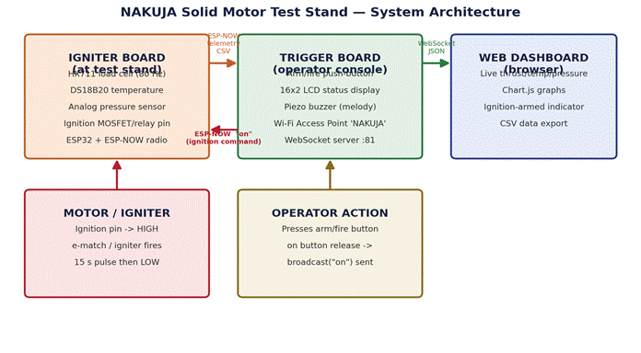
Prepared by Ben Wetu

Table of Contents
1. Introduction & System Overview.................................................................................... 3
1.1 Why This Separation Matters.................................................................................. 3
2. Hardware Involved in the Ignition Path........................................................................... 3
2.1 The Critical Path..................................................................................................... 4
3. Step-by-Step: How Ignition Is Triggered.......................................................................... 5
Step 1 — Operator presses and releases the arm/fire button......................................... 5
Step 2 — Trigger Board broadcasts the ignition command.............................................. 5
Step 3 — Trigger Board gives operator feedback............................................................ 5
Step 4 — Igniter Board receives and validates the command.......................................... 5
Step 5 — Ignition pin is driven HIGH.............................................................................. 5
Step 6 — Automatic cut-off after 15 seconds................................................................. 6
4. Ignition Sequence Diagram............................................................................................ 6
5. Timing Behaviour of the Ignition Pin............................................................................... 7
5.1 Why a Fixed Timer Instead of a Manual Hold............................................................ 7
6. Safety Mechanisms and Failure Handling........................................................................ 8
6.1 Boot-Time Safety Default........................................................................................ 8
6.2 Exact-Match Command Validation........................................................................... 8
6.3 Self-Terminating Burn Window................................................................................ 8
7. Telemetry Running Alongside Ignition............................................................................ 9
7.1 Data Flow Summary................................................................................................ 9

Introduction & System Overview

This report explains, in detail, how the ignition process works on the NAKUJA solid motor static-fire test stand. The system is built from two ESP32 microcontroller boards that communicate wirelessly, plus a browser-based dashboard for the operator. Its job is to let an operator safely trigger ignition of a solid rocket motor from a distance while continuously monitoring thrust, chamber temperature, and chamber pressure.
The system is composed of three cooperating parts:
· Igniter Board — mounted at the test stand itself, next to the motor. It reads sensor data and physically switches the ignition circuit.
· Trigger Board — the operator's console, some distance away. It hosts the arm/fire button, a local display, and a Wi-Fi access point.
· Web Dashboard — a browser page that connects over Wi-Fi to visualize live telemetry and log the test.
The two boards never touch the same wires — they communicate purely over a wireless protocol called ESP-NOW, which is what allows the operator to stand at a safe distance from the motor while still commanding ignition in real time.
1.1 Why This Separation Matters
Keeping the ignition switch physically at the motor (Igniter Board) and the human trigger physically at the operator's console (Trigger Board) is a deliberate safety boundary. The only thing that crosses the gap between operator and motor is a short wireless message — there is no direct electrical path a person could accidentally complete, and the Igniter Board defaults its ignition pin to LOW on every boot regardless of what the Trigger Board is doing. Figure 1 on the title page illustrates this layout; refer back to it whenever the roles of the two boards are mentioned below.

2. Hardware Involved in the Ignition Path
The table below lists every component that plays a role in either sensing the motor or carrying out the ignition command.
Component | Board | Function
HX711 + load cell | Igniter | Measures thrust force, sampled at 80 Hz, 8-sample smoothing
DS18B20 | Igniter | Motor/chamber temperature, read asynchronously once per second
Analog pressure sensor | Igniter | Chamber pressure via ADC, 10-sample rolling average
Ignition MOSFET/relay (GPIO 26) | Igniter | Switches power to the e-match / igniter element
ESP32 + ESP-NOW radio | Both | Low-latency peer-to-peer wireless link between boards
Arm/fire push-button | Trigger | Operator input that initiates the ignition command
16x2 I2C LCD | Trigger | Local read-out of live telemetry and ignition status
Piezo buzzer | Trigger | Audible non-blocking melody cue on ignition
Wi-Fi AP + WebSocket server | Trigger | Bridges ESP-NOW telemetry to the browser dashboard

2.1 The Critical Path
Only a small subset of this hardware is actually in the ignition 'critical path' — the chain of events that must work correctly for ignition to happen safely and on command:
· The push-button on the Trigger Board (physical input).
· The ESP-NOW radio link between the two ESP32s (wireless transport).
· The receiveCallback() handler and ignition pin (GPIO 26) on the Igniter Board (the actual switch).
Everything else — the LCD, buzzer, dashboard, load cell, temperature and pressure sensors — is instrumentation. It informs the operator but is not required for ignition itself to occur.

3. Step-by-Step: How Ignition Is Triggered
This section walks through exactly what happens, in order, from the moment the operator presses the button to the moment the burn ends.

Step 1 — Operator presses and releases the arm/fire button
The button is wired to GPIO 32 on the Trigger Board with INPUT_PULLUP, so it reads HIGH when not pressed and LOW while pressed. The firmware specifically watches for the release edge, not the press itself — the code tracks a buttonDown flag and only fires when the button transitions from pressed back to released. This release-triggered design avoids firing immediately on contact bounce during the press.

Step 2 — Trigger Board broadcasts the ignition command
On a valid release, the Trigger Board calls broadcast("on"), which sends the two-character string "on" as an ESP-NOW packet to the broadcast MAC address (FF:FF:FF:FF:FF:FF). Because ESP-NOW is connectionless and does not require an established Wi-Fi association, this message reaches the Igniter Board within a few milliseconds.

if (digitalRead(STATUS_BUTTON)) {
if (!buttonDown) {
buttonDown = true;
broadcast("on");
// LCD + buzzer feedback follows
}
} else {
buttonDown = false;
}

Step 3 — Trigger Board gives operator feedback
Immediately after sending the command, the Trigger Board updates its LCD to read "! IGNITION !" and starts a short, non-blocking buzzer melody so the operator has audible and visual confirmation that the command was sent — independent of whether the Igniter Board actually received it.

Step 4 — Igniter Board receives and validates the command
The Igniter Board's ESP-NOW receive callback fires as soon as the packet arrives. It copies the incoming bytes into a buffer and compares it against the literal string "on". Only an exact match is accepted; anything else is silently ignored.
void receiveCallback(const esp_now_recv_info_t *recv_info,
const uint8_t *data, int dataLen) {
char buffer[ESP_NOW_MAX_DATA_LEN + 1];
int msgLen = min(ESP_NOW_MAX_DATA_LEN, dataLen);
strncpy(buffer, (const char *)data, msgLen);
buffer[msgLen] = '\0';
if (strcmp(buffer, "on") == 0) {
IGN_STATUS = true;
t_ignition_start = millis();
}
}

Step 5 — Ignition pin is driven HIGH
Setting IGN_STATUS to true and recording t_ignition_start does not itself fire the igniter — it only arms a condition that the main loop() checks on every pass. The main loop continuously evaluates whether IGN_STATUS is true and whether less than 15,000 milliseconds have elapsed since t_ignition_start. While both are true, it drives the ignition pin HIGH, which switches on the circuit feeding the e-match / igniter element in the motor.
if (IGN_STATUS && (millis() - t_ignition_start < 15000)) {
digitalWrite(ign_pin, HIGH);
} else {
digitalWrite(ign_pin, LOW);
IGN_STATUS = false;
}

Step 6 — Automatic cut-off after 15 seconds
There is no separate "off" command from the operator. The Igniter Board is entirely self-timed: once 15,000 milliseconds have elapsed since ignition started, the same condition above becomes false on its own, the pin is driven LOW, and IGN_STATUS resets — returning the board to its safe idle state without requiring any further wireless communication.

4. Ignition Sequence Diagram
Figure 2 lays out the full timeline described in Section 3 as a single diagram, showing which board is responsible for each action and which arrows represent a wireless hop versus a local, on-board decision.
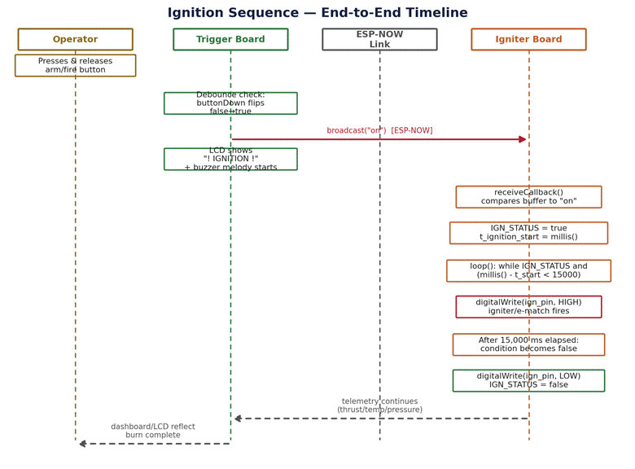
Figure 2. End-to-end ignition timeline across operator, Trigger Board, ESP-NOW link, and Igniter Board.

5. Timing Behavior of the Ignition Pin
Figure 3 shows the relationship between the physical button release, the internal IGN_STATUS flag, and the actual voltage on the ignition pin over time. The important detail is that the pin is only ever HIGH for a fixed, hard-coded 15-second window — there is no way, in the current firmware, to hold ignition on for longer or to retrigger it while it is already active, because IGN_STATUS is simply overwritten with a new start time if a second "on" arrives mid-burn.
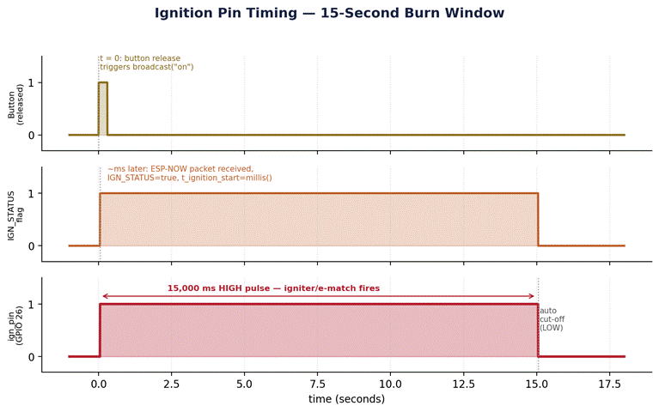
Figure 3. Ignition pin state versus time, referenced against the button release event.

5.1 Why a Fixed Timer Instead of a Manual Hold
Using millis() elapsed-time comparison rather than keeping the button physically held down means the operator's single press-and-release is enough to complete an entire burn. This avoids requiring continuous physical contact during a live-fire test and removes any risk of ignition cutting out early if the operator's hand slips or a wireless retransmission is dropped after the initial command lands.

6. Safety Mechanisms and Failure Handling
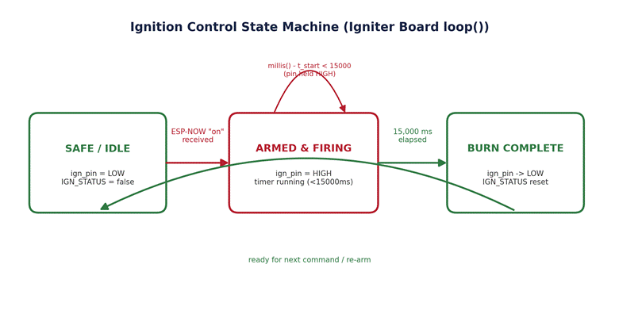
Figure 4. Ignition control states as implemented in the Igniter Board's loop().

6.1 Boot-Time Safety Default
On every power-up or reset, setup() explicitly writes the ignition pin LOW before anything else happens: digitalWrite(ign_pin, LOW). This guarantees the circuit cannot be left in an energized state by an uninitialized pin during boot, which is one of the more common causes of unintended firing in microcontroller-driven ignition systems.

6.2 Exact-Match Command Validation
The receive callback uses strcmp() for an exact match against "on" rather than checking for a substring or prefix. Random noise, a corrupted packet, or an unrelated ESP-NOW broadcast on the same channel is extremely unlikely to coincidentally match this exact string, which reduces the chance of spurious ignition.

6.3 Self-Terminating Burn Window
Because the 15-second cut-off is computed locally on the Igniter Board from its own clock, the Trigger Board does not need to remain connected, send a stop command, or stay powered for the ignition sequence to terminate safely. A dropped wireless link after the initial trigger cannot leave the pin stuck HIGH indefinitely.

7. Telemetry Running Alongside Ignition
While ignition is armed and firing, the Igniter Board does not pause its sensor loop. Thrust is sampled continuously from the HX711 at 80 Hz, chamber temperature is refreshed once per second from the DS18B20, and pressure is averaged from ten ADC readings each time new load-cell data is ready. Every time the load cell reports a new sample, the Igniter Board packages thrust, temperature, and pressure into a single CSV string and broadcasts it over the same ESP-NOW link used for the ignition command.
The Trigger Board receives this telemetry, converts it to JSON, and republishes it over its WebSocket server, which is what the browser dashboard displays as live charts and logs to CSV. This means the same wireless channel that carries the one-time ignition command also carries continuous burn data, so the operator can watch thrust rise in real time immediately after triggering ignition.

7.1 Data Flow Summary
· Igniter Board -> ESP-NOW -> Trigger Board: telemetry CSV string (thrust, temperature, pressure).
· Trigger Board -> WebSocket -> Dashboard: same data re-encoded as JSON for the browser.
· Trigger Board -> ESP-NOW -> Igniter Board: single "on" ignition command, sent once per button release.

